HIT3061 – Software Team Project - Semester 2, 2013

Tremor Detection with Leap Motion

Software Requirements Specification

**Daniel Corsaletti**

SID: 6450458

E: 6450458@student.swin.edu.au

M: 0433 536 150

**Joshua Stopper**

SID: 5571391

E: 5571391@student.swin.edu.au

M: 0430 714 887

**Shengwei Li**

SID: 749999x

E: 749999x@student.swin.edu.au

M: 0420 478 750

**Minh Duc Nguyen**

SID: 171001x

E: 171001x@student.swin.edu.au

M: 0412 179 265

**Tran Xuong Tran**

SID: 6700691

E: 6700691@student.swin.edu.au

M: 0433 345 105

**Table 1. Document Change Control**

|  |  |  |  |
| --- | --- | --- | --- |
| Version | Date | Author | Changes |
| 0.1 | 27/08/2013 | Joshua Stopper | Create Document  Create Content Areas  Names added |
| 0.9 | 02/09/2013 | Joshua Stopper | Continue to fill out remain sections |
| 0.91 | 02/09/2013 | Minh Duc Nguyen | Continue Section 4 |
| 0.92 | 02/09/2013 | Tran Xuong Tran | Continue Section 2 |
| 0.93 | 04/09/2013 | Tran Xuong Tran | Reformat some content |
| 1.1 | 16/09/2013 | Daniel Corsaletti | Clean up some sections, fix some incorrect information |
| 1.2 | 04/10/2013 | Daniel Corsaletti | Fix some data based on feedback received from supervisor |
| 1.3 | 05/10/2013 | Tran Xuong Tran | Changing section 3 |
| 1.4 | 06/10/2013 | Tran Xuong Tran | Edit section 3 |
| 1.5 | 15/10/2013 | Daniel Corsaletti | Reviewed document based on feedback |
| 1.6 | 26/10/2103 | Daniel Corsaletti | Reviewed document based on feedback |
| 2.0 | 04/11/2013 | Daniel Corsaletti & Josh Stopper | Update application architecture and review based on feedback |

**Table 2. Document Sign Off**

|  |  |  |
| --- | --- | --- |
| Name | Signature | Date |
| Joshua Stopper |  |  |
| Minh Duc Nguyen |  |  |
| Tran Xuong Tran |  |  |
| Daniel Corsaletti |  |  |
| Shengwei Li |  |  |

Table of Contents

1 Introduction 3

1.1 Purpose 3

1.2 Scope 3

*1.3* Definitions, Acronyms and Abbreviations 4

2 Overall Description 4

2.1 Application Features 4

2.2 Application Requirements 4

2.2.1 Development Requirements 4

2.2.2 Production Requirements 5

2.2.3 Hardware Requirements 5

2.2.4 Software Requirements 5

*2.3* Documentation 6

3 Application Architecture 6

4 Interface Requirements 7

4.1 User Interfaces 7

4.2 Hardware Interfaces 7

4.3 Software Interfaces 7

5 Bibliography: 8

# Introduction

Over one year ago, Dr. Philip Michael from the Royal Victorian Eye & Ear hospital discovered the capability of the Leap Motion Device to track 1/100th of a millimeter changes in the location of fingers at up to 200 times a second. In an attempt to advance the state of the industry, Dr. Philip Michael has brought the project to Swinburne University to make the advancement a reality.

In collaboration with Swinburne University, Dr. Philip Michael and select students, a project was created to use the Leap Motion Device to attempt to detect tremors in surgeon’s hands whilst outputting a variety of attributes relating to their tremor.

After continued analysis of the Leap Motion device by Dr. Philip Michael, he believed the potential use cases for such a solution could expand from not only a surgeon’s hand but also to patients with Parkinson’s disease. The potential outcome of the controller and developed application in this case will provide doctors as well as patients the ability to see the level of progression of the disease, as well as whether or not medications to treat the disease are working, however this stage of development is more of a proof of concept.

## Purpose

The purpose of this document is to detail the requirements of the project so that an application can be developed that meets the requirements. As such, this document is for the client and the developers so that an agreement can be reached.

## Scope

**Name**

* Tremor Detection with Leap Motion

**What the application will do**

* Display the attributes of tremor in the hand, providing the amplitude, velocity, acceleration and frequency of the tremor
* Display brief introduction on how to use the application
* Display instructions to the user in real time

**What the application will not do**

* Provide a specific rating of how severe or mild a tremor is
* Provide a concrete output whether the surgeon is ready for operation
* Provide liability in the event that a surgeon has a tremor during operation

**Application and potential outcomes of the full development of application**

* Used by surgeons to test their hands pre-operative to determine if they are able to perform
* Used by doctors clinics, testing tremors in Parkinson’s patients
  + Comparing past results of patients

**Benefits of the application**

* Tremor can be detected in real time without expensive hardware
* Tremor can be detected in a non-intrusive way

**Objective of the application**

* To show that it is possible to develop an application that will interface with the Leap Motion Device and detect the level of tremor in the hand. This includes measuring the frequency, velocity, acceleration and amplitude of tremors.

## Definitions, Acronyms and Abbreviations

|  |  |
| --- | --- |
| **Word** | **Definition** |
| LM | Leap Motion |
| LMD | Leap Motion Device |
| API | Application Programming Interface |
| JSAPI | JavaScript Application Programming Interface |
| Hertz | Unit of frequency that defines a rate of change. Hertz defines the rate of change |

# Overall Description

The application we will be developing will be used as a proof of concept for our client to prove that we are able to use a LMD to correctly identify and measure a tremor in a user’s hand. The application may be used by our client for his own tests; however we are tasked with proving that this device is able to effectively accomplish what other more expensive and intrusive hardware is able to do.

## Application Features

* Ability to detect the tremor in a user’s hands and analyze the different attributes of the tremor
* Application possesses ability to measure the amplitude, frequency, acceleration and velocity of a user’s tremor and display this information to the user
* Instructions on how to complete test are available in real time, giving the user feedback on how to use the application correctly

## Application Requirements

In order to develop and run the application we need to define what requirements are needed. As our development environment and our production environment differ, we have identified what is necessary for each of these environments separately. Our application will also be developed to run in different operating systems, we have outlined what operating systems are ideal and required hardware for a system running the application.

### Development Requirements

|  |  |
| --- | --- |
| **Requirement** | **Explanation** |
| LMD | This device is what records the motion and sends the data to the computer |
| LM Driver | This software interfaces with the Leap Motion device and converts the binary into usable data |
| LM JSAPI | The Leap Motion JSAPI provides a javascript interface to the Leap Motion device. |
| Computer | The computer will perform the calculations required by the application |
| Local Web Server | This software will host the code for execution in a web browser |
| Web Browser (Chrome/Firefox/IE/Safari) | The web browser will run the application developed |
| IDE/Text Editor | The application will be developed in this software. |

### Production Requirements

|  |  |
| --- | --- |
| **Requirement** | **Explanation** |
| LMD | This device is what records the motion and sends the data to the computer |
| LM Driver | This software interfaces with the Leap Motion Device and converts the binary into usable data |
| LM JSAPI | The Leap Motion JSAPI provides a Javascript interface to the leap motion device. The JSAPI will be included when the web page is loaded, therefore not required locally |
| Computer | The computer will perform the calculations required by the application |
| Web Browser (Chrome/Firefox/IE/Safari) | The web browser will run the application developed |

### Hardware Requirements

|  |  |
| --- | --- |
| **Component** | **Minimum Requirements** |
| Processor | AMD Phenom ™ II or Intel® Core™ i3, i5, i7 |
| Memory | 2 GB RAM |
| Connection | USB 2.0 port |
| Peripheral | LMD |

### Software Requirements

|  |  |
| --- | --- |
| **Software Requirements** | |
| Operating System | Windows® 7 or 8 or Mac® OS X 10.7 |
| Browser | Chrome/Firefox/IE/Safari |

## Documentation

* User manual for running and installing application
* Technical manual for any future developments
* Source code of the developed application
* Testing documentation during the building of the application

# Application Architecture

The architecture of our application is outlined below in Figure 1. The application will run in a HTML page in the user’s browser. Bootstrap will be used to design the user interface and we will also use the functionality from the Jquery library and the LM JSAPI. The Frame Controller is the function that is capable of looping through each frame of data that is passed from the LMD to the application and performs the required functionality to display the results on screen, validate whether the captured data is valid and extracts the raw data from the frames. This is also where we will analyze the attributes of a tremor in the captured data.

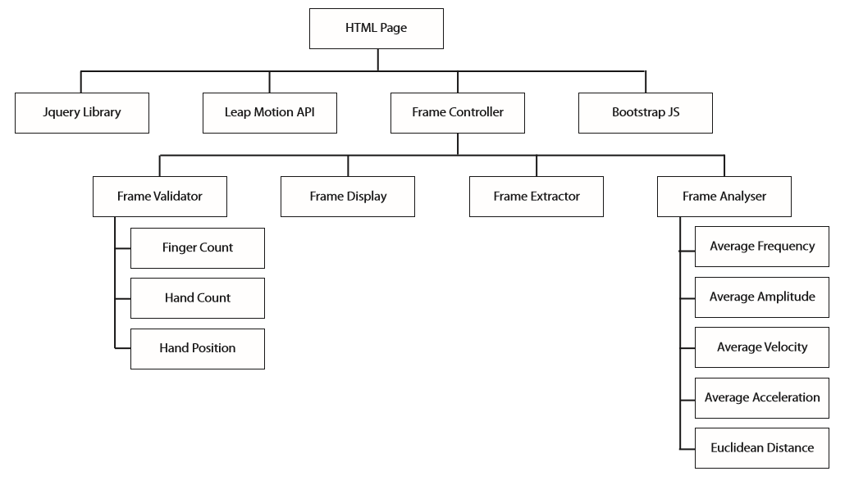

Figure 1 Application Architecture

# Interface Requirements

## User Interfaces

When the application is running it will require the LMD to be plugged in to work correctly. The user will be told to interact with the application directly by using their LMD (Figure 2 shows an example of how the Leap Motion Device is used). The user will be able to see a frame showing the movement of their hand on the screen and instructions will appear about where they should hold their hand. The application will give the user feedback about where they need to move their hand to be in ideal testing range. Once in the correct position for a certain amount of time the application will inform the user that the test is about to begin.

|  |
| --- |
|  |
| Figure 2. Example of how LMD is used. Hand movements above the sensor will be captured by the device and can be accessed at a later stage. |

The user will then hold their hand in position for the duration of the analysis and the application will notify them when their test has completed. Once complete, the results of a user’s test will be displayed on the screen, showing detailed attributes of their tremor.

## Hardware Interfaces

The application will be executable on any machine that is able to successfully install the LM drivers. We will also develop the application to be used across both Mac and Windows operating systems. The only physical interfaces this application requires is a USB port for the LMD to connect to.

## Software Interfaces

The application we develop will not need to interface with a database as the results of the test will not need to be saved. The data will simply be displayed on screen for the user.

# Bibliography:

Js.leapmotion.com. 2013. *leapjs*. [online] Available at: http://js.leapmotion.com/ [Accessed: 17 Sep 2013].

Motion, L. 2013. *Leap Motion*. [online] Available at: https://www.leapmotion.com/ [Accessed: 17 Sep 2013].

Support, L. 2013. *What are the system requirements?*. [online] Available at: http://support.leapmotion.com/entries/23822921-What-are-the-system-requirements- [Accessed: 17 Sep 2013].